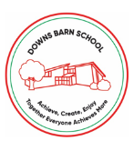
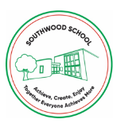
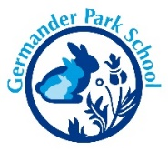

COVID-19 Risk Assessment Update - 4th November 2021

Measures already in place that all staff and children should be adhering to:
- Twice weekly LFD testing for staff
- Good hand hygiene
- Good ventilation in rooms
- Following self-isolation guidance (see below)
- Supporting contact tracing
- Children come to school in PE kits
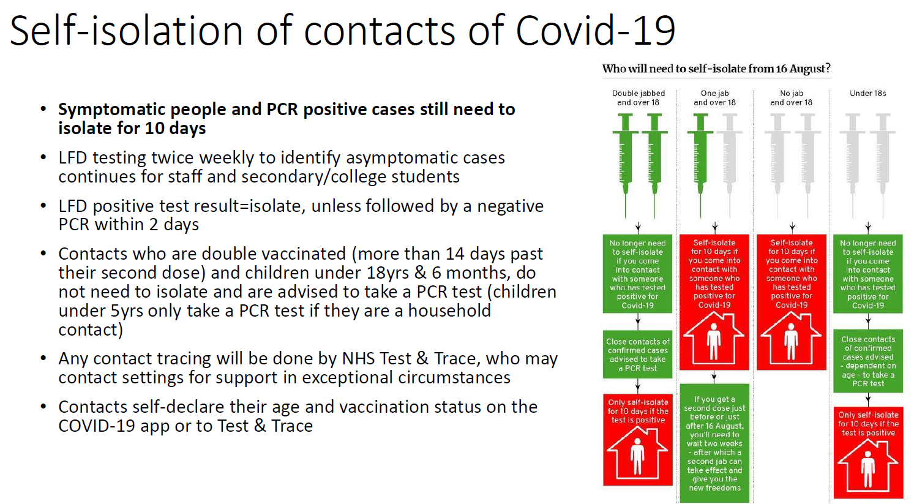
New Measures from 5th November 2021:
- Face coverings to be worn by staff outside classrooms
- Indoor gatherings to be reduced
- Assemblies to be via Zoom
- Breaks and lunchtimes – children to be in separate play spaces, if possible
- No whole school team meetings
- Staff rooms are not used for communal gathering, just for access to fridge and hot water
- Children are separated in schools for Breakfast Club and ACERs
- Visits take place, but with enhanced hand hygiene and wash-do-wash mantra
- Regulation Stations should not be used
- At Southwood, Kaleidoscope takes place in classrooms
- Nativity performance/ virtual to be confirmed at end of November
- Christmas fayre to be confirmed by end of November

Outbreak Management Plan
Should Public Health require the schools to implement more significant measures, the schools would revert back to all measures outlined in the March 2021 Re-opening Models.

