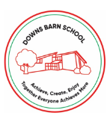
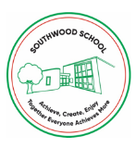


COVID-19 Risk Assessment Update – 24th January 2022

Measures already in place that all staff and children should be adhering to:
- Twice weekly LFD testing for staff
- Good hand hygiene
- Good ventilation in rooms
- Following self-isolation guidance (see below)
- Supporting contact tracing
- Children come to school in PE kits
- Follow England’s Self Isolation guidance from the UK Government

Measures from 24th January 2022:
- Face coverings to be worn by staff outside classrooms
- Indoor gatherings to be reduced
- Assemblies to be via Zoom
- No whole school team meetings, unless necessary
- Staff rooms are not used for communal gathering, just for access to fridge and hot water
- Children are separated in schools for Breakfast Club and ACERs
- Visits take place, but with enhanced hand hygiene and wash-do-wash mantra
- Regulation Stations should not be used
- Parents and Carers not to be invited into school for assemblies/presentations

Outbreak Management Plan
Should Public Health require the schools to implement more significant measures, the schools would revert back to all measures outlined in the March 2021 Re-opening Models.

