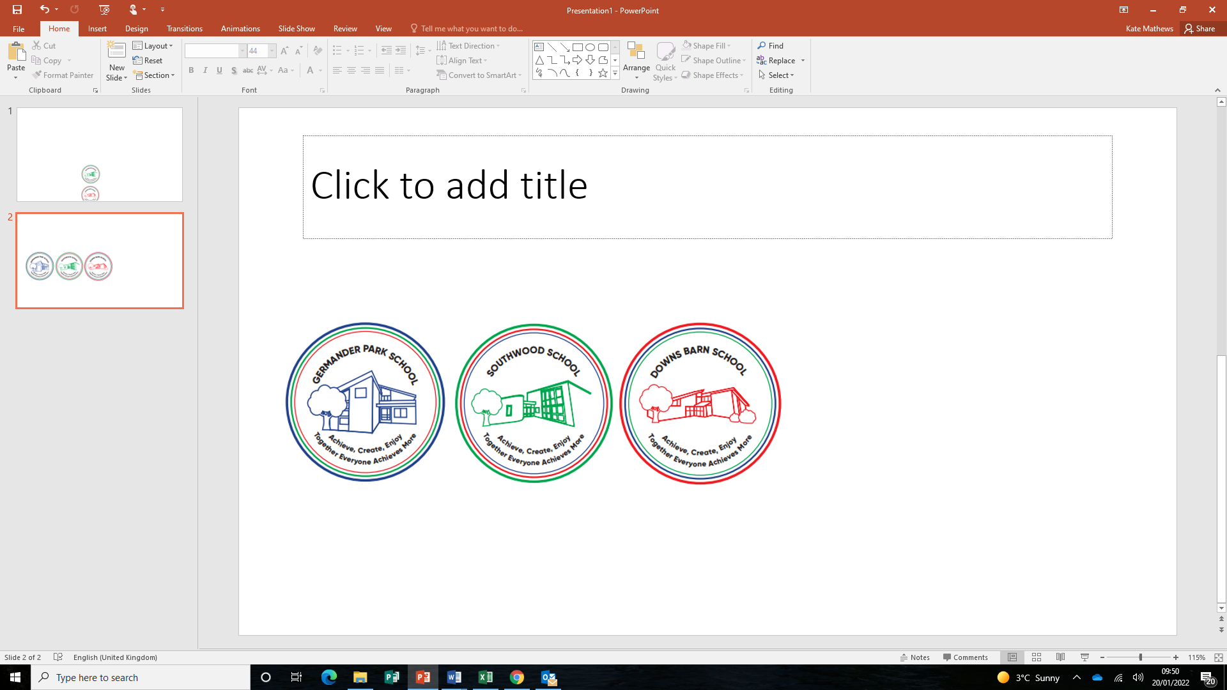
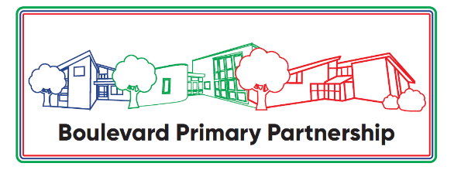

Boulevard Primary Partnership

Admissions Policy for September 2026

Written: July 2025

Approved by Governors: July 2025

Date for review: June 2026
SOUTHWOOD SCHOOL

ADMISSION ARRANGEMENTS SEPTEMBER 2026

Southwood is a 7-11 junior school. Entry to the school takes place in September when Year 3 pupils will be admitted. The school does not operate a selection process and places are available for pupils in line with our Equalities Policy and irrespective of where a pupil lives.

The Defined Area
City Centre North, Conniburrow, Downs Barn, Downhead Park South and Campbell Park, North of the Park. The exact defined area can be seen on the attached map.

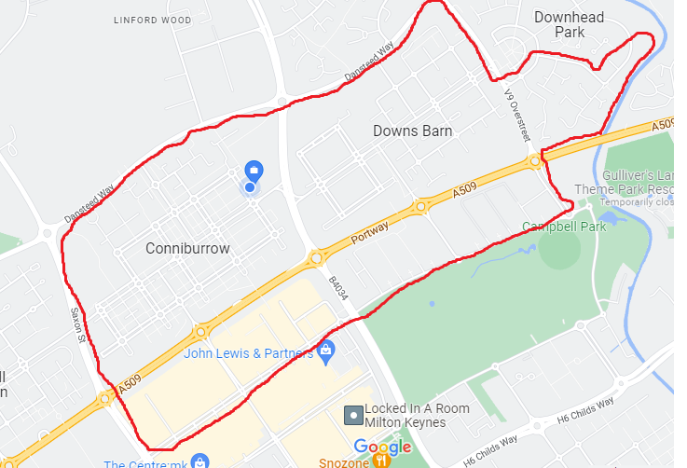

Admissions Procedure
Children will be admitted to Southwood School at the age of 7. Any parent, wherever the family lives, wishing for a place at Southwood must complete the Local Authority’s application online process. This can be found at https://www.milton-keynes.gov.uk/schools-and-lifelong-learning/school-admissions.

Any parent, wherever the family lives, wishing for a place at Southwood School must complete the Local Authority’s application form online at https://www.milton-keynes.gov.uk/schools-and-lifelong-learning/school-admissions .
Procedures for applying to Southwood School are explained in the Council’s “Applying for a
primary / junior school place in Milton Keynes: A guide for parents and carers” booklet, which can be found online at https://www.milton-keynes.gov.uk/schools-and-lifelong-learning/school-admissions/starting-primary-or-juniormiddle-school-september.
Parents should familiarise themselves with this information and take a particular note of the definitions provided, dates and deadlines. Milton Keynes Council co-ordinates admissions to all primary schools in Milton Keynes and parents cannot apply directly to the school.

Although Southwood School is the admissions authority, the Local Authority, as required by the Department for Education co-ordinates the admission arrangements for all schools/academies in Milton Keynes and will communicate all admission decisions to parents for entry to Year. Decisions on September intake admissions are usually made in March when parents will be informed and offered a place by Milton Keynes Council on behalf of the Governing Body.

If a place is required during the school year, for example when a family moves into the area, parents should still apply via the Local Authority.

Fraudulent Information If the allocation of a place has been made on the basis of fraudulent or intentionally misleading information, the Governors reserve the right to withdraw the place.

Oversubscriptions Criteria
Priority will be given to children with an Educational Health Care Plan (EHCP), naming Southwood, in the normal round of admissions for children transferring at 7 +.

The Published Admission Number (PAN) for Year 3 in September 2026 is 60.

In the event that there are more applications than places available, applications will be ranked as per the oversubscription criteria as follows:

1.Children who are looked after (LAC) and all previously looked after children (PLAC) including those children who appear (to the admission authority) to have been in state care outside of England and ceased to be in state care as a result of being adopted (IAPLAC).

2.Children eligible for the service premium*.

3. Siblings of children who are attending the school at the time allocations are made and are expected to be on roll at the school at the time of the proposed admission and the place of residence is within the catchment area of the school.

4.The child’s place of residence is within the catchment area of the school and there is no sibling.

5.Siblings of children who are attending the school at the time allocations are made and are expected to be on roll at the school at the time of the proposed admission and the place of residence is outside of the catchment area of the school.

6.Children of staff at the school where the member of staff has been employed at the school for two or more years at the time at which the application for admission to the school is made, and /or the member of staff is recruited to fill a vacant post for which there is a demonstrable skill shortage.

7.“Distance” from the school to the place of residence.

(*) The service premium is additional funding paid annually to schools under Section 14 of the Education Act 2002 for the purposes of supporting the pastoral needs of the children of Armed Services personnel.

In the event of there being more applicants meeting any of the criteria above, places will be allocated in distance order using the distance between the child’s normal home address and the school’s main entrance, measured in a straight line, using the council’s computerised measuring system with those living closest to the school receiving the higher priority. In the unlikely event of joint oversubscription, having exhausted distance, random allocation will be used as the ultimate tie-breaker.

For applicants living in flats, the distance will be measured from the school’s main entrance to the front door of the ground floor flat underneath the applicant’s main residence. Where two or more pupils live at the same distance, the tie-breaker will be random allocation.

In the case of multiple births, places will be offered to all children, even if this takes us over the admission number of the school.

A sibling is a brother or sister, which for admission purposes means brothers and sisters of whole or half blood or any other child (including an adopted child) who permanently resides at the same address and for whom the parent also has parental responsibility.

If it is not possible to offer your child a place at this school then you will be advised about how you can appeal against that decision. The Local Authority will also let you know about available places at other schools. The PAN for Southwood School is 60 pupils.

Late Applications
Late applications will be acknowledged and if places are unavailable, the child will be placed on the school’s waiting list in criteria order.

Waiting List
A waiting list will be maintained in the order of the oversubscription criteria and families will be contacted to see if they wish to remain on the list.
The waiting list will remain until 31st December of each school year of admission. Each added child will require the list to be ranked again in line with the published oversubscription criteria.
The waiting list will be checked when a pupil vacancy arises, or when a child is removed from the allocation list

Independent Admissions Appeal Committee
Parents who are not offered a place for their child in the Year 3 Class are entitled to appeal to an independent committee under provisions of the School Standards and Framework Act 1998 as amended by section 40 of the Education & Inspections Act 2006. Parents wishing to appeal in these circumstances should contact the school office for an Appeal Form.

GERMANDER PARK SCHOOL

ADMISSION ARRANGEMENTS SEPTEMBER 2026

Germander Park is a 2 – 7 Infant school and Nursery.

For the Nursery:

The school will offer children a place in the Nursery for the term after their second birthday, according to the criteria below. A place in our nursery does not automatically confer admission to the school. A child will remain in the Nursery until the end of the academic year in which they are 4 years old.

Provision is offered for either:
• 15 hours – five mornings or five afternoons per week (additional sessions can be attended, subject to availability and a payment of £15 per session)
• 30 hours – five days a week, all day (by qualifying for 30 hours of free childcare)

Nursery class sessions are from 8.45am to 11.45am and from 12.15pm to 3.15pm. Admissions forms are available from the school office.

In the event that there are more applications than places available in the Nursery, applications will be ranked as per the oversubscription criteria as follows:

1.Children who are looked after (LAC) and all previously looked after children (PLAC) including those children who appear (to the admission authority) to have been in state care outside of England and ceased to be in state care as a result of being adopted (IAPLAC).

2.Children eligible for the service premium*.

3. Siblings of children who are attending the school at the time allocations are made and are expected to be on roll at the school at the time of the proposed admission and the place of residence is within the catchment area of the school.

4.The child’s place of residence is within the catchment area of the school and there is no sibling.

5.Siblings of children who are attending the school at the time allocations are made and are expected to be on roll at the school at the time of the proposed admission and the place of residence is outside of the catchment area of the school.

6.Children of staff at the school where the member of staff has been employed at the school for two or more years at the time at which the application for admission to the school is made, and /or the member of staff is recruited to fill a vacant post for which there is a demonstrable skill shortage.

7.“Distance” from the school to the place of residence.

(*) The service premium is additional funding paid annually to schools under Section 14 of the Education Act 2002 for the purposes of supporting the pastoral needs of the children of Armed Services personnel.

In the event of there being more applicants meeting any of the criteria above, places will be allocated in distance order using the distance between the child’s normal home address and the school’s main entrance, measured in a straight line, using the council’s computerised measuring system with those living closest to the school receiving the higher priority. In the unlikely event of joint oversubscription, having exhausted distance, random allocation will be used as the ultimate tie-breaker.

For applicants living in flats, the distance will be measured from the school’s main entrance to the front door of the ground floor flat underneath the applicant’s main residence. Where two or more pupils live at the same distance, the tie-breaker will be random allocation.

In the case of multiple births, places will be offered to all children, even if this takes us over the admission number of the school.

A sibling is a brother or sister, which for admission purposes means brothers and sisters of whole or half blood or any other child (including an adopted child) who permanently resides at the same address and for whom the parent also has parental responsibility.

For the Infant School:

Entry to the school takes place in September when Reception pupils will be admitted. The school does not operate a selection process and places are available for pupils in line with our Equalities Policy and irrespective of where a pupil lives.

The Defined Area
Conniburrow including Dansteed Way, Silbury Boulevard, Saxon Gate, Marlborough Street, including up to North Thirteenth Street, Witan Gate West and Portway. The exact defined area can be seen on the attached map.

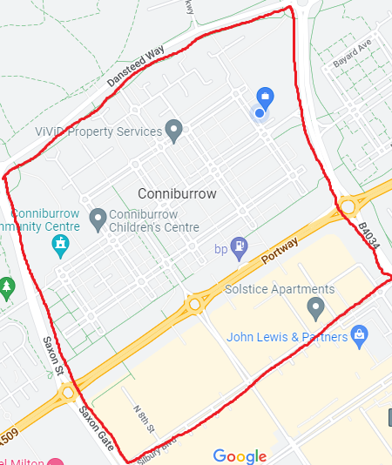

Admissions Procedure
Children start school for the first time in the September following their fourth birthday. By law, a child must have started school at the beginning of the term following their fifth birthday. Any parent, wherever the family lives, wishing for a place at Germander Park must complete the Local Authority’s application form online at https://www.milton-keynes.gov.uk/schools-and-lifelong-learning/school-admissions.

Procedures for applying to Germander Park School are explained in the Council’s “Applying for a
primary / junior school place in Milton Keynes: A guide for parents and carers” booklet, which can be found online at https://www.milton-keynes.gov.uk/schools-and-lifelong-learning/school-admissions/starting-primary-or-juniormiddle-school-september.
Parents should familiarise themselves with this information and take a particular note of the definitions provided, dates and deadlines. Milton Keynes Council co-ordinates admissions to all primary schools in Milton Keynes and parents cannot apply directly to the school.

Although Germander Park School is the admissions authority, the Local Authority, as required by the Department for Education co-ordinates the admission arrangements for all schools/academies in Milton Keynes and will communicate all admission decisions to parents. Decisions on September admissions are usually made in March when parents will be informed and offered a place by Milton Keynes Council on behalf of the Governing Body.

If a place is required during the school year, for example when a family moves into the area, parents should still apply via the Local Authority.

Fraudulent Information If the allocation of a place has been made on the basis of fraudulent or intentionally misleading information, the Governors reserve the right to withdraw the place.

Oversubscriptions Criteria
Priority will be given to children with an Educational Health Care Plan (EHCP), naming Germander Park, in the normal round of admissions for children starting school for the first time.

The Published Admission Number (PAN) for Year R in September 2026 is 30.

In the event that there are more applications than places available, applications will be ranked as per the oversubscription criteria as follows:

1.Children who are looked after (LAC) and all previously looked after children (PLAC) including those children who appear (to the admission authority) to have been in state care outside of England and ceased to be in state care as a result of being adopted (IAPLAC).

2.Children eligible for the service premium*.

3. Siblings of children who are attending the school at the time allocations are made and are expected to be on roll at the school at the time of the proposed admission and the place of residence is within the catchment area of the school.

4.The child’s place of residence is within the catchment area of the school and there is no sibling.

5.Siblings of children who are attending the school at the time allocations are made and are expected to be on roll at the school at the time of the proposed admission and the place of residence is outside of the catchment area of the school.

6.Children of staff at the school where the member of staff has been employed at the school for two or more years at the time at which the application for admission to the school is made, and /or the member of staff is recruited to fill a vacant post for which there is a demonstrable skill shortage.

7.“Distance” from the school to the place of residence.

(*) The service premium is additional funding paid annually to schools under Section 14 of the Education Act 2002 for the purposes of supporting the pastoral needs of the children of Armed Services personnel.

In the event of there being more applicants meeting any of the criteria above, places will be allocated in distance order using the distance between the child’s normal home address and the school’s main entrance, measured in a straight line, using the council’s computerised measuring system with those living closest to the school receiving the higher priority. In the unlikely event of joint oversubscription, having exhausted distance, random allocation will be used as the ultimate tie-breaker.

For applicants living in flats, the distance will be measured from the school’s main entrance to the front door of the ground floor flat underneath the applicant’s main residence. Where two or more pupils live at the same distance, the tie-breaker will be random allocation.

In the case of multiple births, places will be offered to all children, even if this takes us over the admission number of the school.

A sibling is a brother or sister, which for admission purposes means brothers and sisters of whole or half blood or any other child (including an adopted child) who permanently resides at the same address and for whom the parent also has parental responsibility.

If it is not possible to offer your child a place at this school then you will be advised about how you can appeal against that decision. The Local Authority will also let you know about available places at other schools. The PAN for Germander Park School is 30 pupils.

Late Applications
Late applications will be acknowledged and if places are unavailable, the child will be placed on the school’s waiting list in criteria order.

Waiting List
A waiting list will be maintained in the order of the oversubscription criteria and families will be contacted to see if they wish to remain on the list.
The waiting list will remain until 31st December of each school year of admission. Each added child will require the list to be ranked again in line with the published oversubscription criteria.
The waiting list will be checked when a pupil vacancy arises, or when a child is removed from the allocation list.

Independent Admissions Appeal Committee
Parents who are not offered a place for their child in the Year R Class are entitled to appeal to an independent committee under provisions of the School Standards and Framework Act 1998 as amended by section 40 of the Education & Inspections Act 2006. Parents wishing to appeal in these circumstances should contact the school office for an Appeal Form.

Downs Barn School Nursery

69 Downs Barn Boulevard, Downs Barn, Milton Keynes, MK14 7NA
The catchment area is Downs Barn, Campbell Park north of the park and the following roads on Downhead Park: Colesbourne Drive (61 odds upwards and 66 evens upwards), Daylesford court, Fairford Crescent (nos 2 to 14 only), Kirtlington, Oakley Gardens, Thorneycroft Lane (even nos) and Warmington Gardens
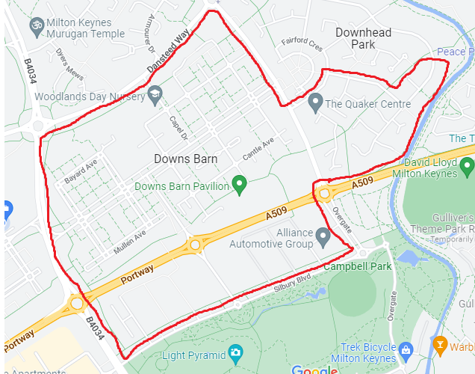

Downs Barn is a 2 – 7 Infant school and Nursery.

For the Nursery:

The school will offer children a place in the Nursery for the term after their second birthday, according to the criteria below. A place in our nursery does not automatically confer admission to the school. A child will remain in the Nursery until the end of the academic year in which they are 4 years old.

Provision is offered for either:
• 15 hours – five mornings or five afternoons per week (additional sessions can be attended, subject to availability and a payment of £15 per session)
• 30 hours – five days a week, all day (by qualifying for 30 hours of free childcare)

Nursery class sessions are from 8.45am to 11.45am and from 12.15pm to 3.15pm. Admissions forms are available from the school office.

The school will offer children a place in the Nursery in the term after their second birthday, according to the criteria below. A place in our nursery does not automatically confer admission to the school. A child will remain in the Nursery until the end of the academic year in which they are 4 years old.

Provision is offered for either:
- 15 hours – five mornings or five afternoons per week (additional sessions can be attended, subject to availability and a payment of £10 per session)
- 30 hours – five days a week, all day (by qualifying for 30 hours free childcare)
Nursery class sessions are from 8.45am to 11.45am and from 12.15pm to 3.15pm.
Admissions forms are available from the school office.

In the event that there are more applications than places available, applications will be ranked as per the oversubscription criteria as follows:

1.Children who are looked after (LAC) and all previously looked after children (PLAC) including those children who appear (to the admission authority) to have been in state care outside of England and ceased to be in state care as a result of being adopted (IAPLAC).

2.Children eligible for the service premium*.

3. Siblings of children who are attending the school at the time allocations are made and are expected to be on roll at the school at the time of the proposed admission and the place of residence is within the catchment area of the school.

4.The child’s place of residence is within the catchment area of the school and there is no sibling.

5.Siblings of children who are attending the school at the time allocations are made and are expected to be on roll at the school at the time of the proposed admission and the place of residence is outside of the catchment area of the school.

6.Children of staff at the school where the member of staff has been employed at the school for two or more years at the time at which the application for admission to the school is made, and /or the member of staff is recruited to fill a vacant post for which there is a demonstrable skill shortage.

7.“Distance” from the school to the place of residence.

(*) The service premium is additional funding paid annually to schools under Section 14 of the Education Act 2002 for the purposes of supporting the pastoral needs of the children of Armed Services personnel.

In the event of there being more applicants meeting any of the criteria above, places will be allocated in distance order using the distance between the child’s normal home address and the school’s main entrance, measured in a straight line, using the council’s computerised measuring system with those living closest to the school receiving the higher priority. In the unlikely event of joint oversubscription, having exhausted distance, random allocation will be used as the ultimate tie-breaker.

For applicants living in flats, the distance will be measured from the school’s main entrance to the front door of the ground floor flat underneath the applicant’s main residence. Where two or more pupils live at the same distance, the tie-breaker will be random allocation.

In the case of multiple births, places will be offered to all children, even if this takes us over the admission number of the school.

Appendix 1 – Local Authority Guidance for Admissions to Downs Barn School

Downs Barn School

69 Downs Barn Boulevard, Downs Barn, Milton Keynes, MK14 7NA
The catchment area is Downs Barn, Campbell Park north of the park and the following roads on Downhead Park: Colesbourne Drive (61 odds upwards and 66 evens upwards), Daylesford Court, Fairford Crescent (no’s 2 to 14 only), Kirtlington, Oakley Gardens, Thorneycroft Lane (even no’s) and Warmington Gardens
Key Facts
Type of School | Community
DfE number | 8262313
Admission Authority | Milton Keynes City Council
Age range | 4-7
Telephone | 01908 604430
Email | office@downsbarnschool.co.uk
Website | www.boulevardprimarypartnership.org.uk
Places available in Year R for September 2026 | 30
Supplementary form required | No
Number of applications received for admission in September 2025
Number of places offered on national offer day 2025
Nursery class attached to school | Yes
Special provision | None
Wraparound Care | Breakfast Club available offsite. After School Club available offsite.  Please see school website for more details.

Summary of oversubscription criteria
In the event that there are more applications than places available, applications will be ranked as follows:
- Children who are looked after (LAC) and all previously looked after children (PLAC) including those children who appear (to the admission authority) to have been in state care outside of England and ceased to be in state care as a result of being adopted (IAPLAC).
- Children eligible for the service premium¹
- Siblings of children who are attending the school at the time allocations are made and are expected to be on roll at the school at the time of the proposed admission and the place of residence is within the catchment area of the school
- The child’s place of residence is within the catchment area of the school and there is no sibling
- Siblings of children who are attending the school at the time allocations are made and are expected to be on roll at the school at the time of the proposed admission and the place of residence is outside of the catchment area of the school
- Children of staff at the school where the member of staff has been employed at the school for two or more years at the time at which the application for admission to the school is made, and /or the member of staff is recruited to fill a vacant post for which there is a demonstrable skill shortage
- “Distance” from the school to the place of residence
¹The service premium is additional funding paid annually to schools under Section 14 of the Education Act 2002 for the purposes of supporting the pastoral needs of the children of Armed Services personnel.
In the event of there being more applicants meeting any of the criteria above, places will be allocated in distance order using the distance between the child’s normal home address and the school’s main entrance, measured in a straight line, using the council’s computerised measuring system with those living closest to the school receiving the higher priority. In the unlikely event of joint oversubscription, having exhausted distance, random allocation will be used as the ultimate tie-breaker.
For applicants living in flats, the distance will be measured from the school’s main entrance to the front door of the ground floor flat underneath the applicant’s main residence. Where two or more pupils live at the same distance, the tie-breaker will be random allocation.
Please refer to the council’s website for a detailed copy of the admission arrangements for children starting school for the first time in September 2026.

